Graded Project 3 – Python for DS

- Home Screen when executing the Python App and visit the local server via browser https://127.0.0.1:5000

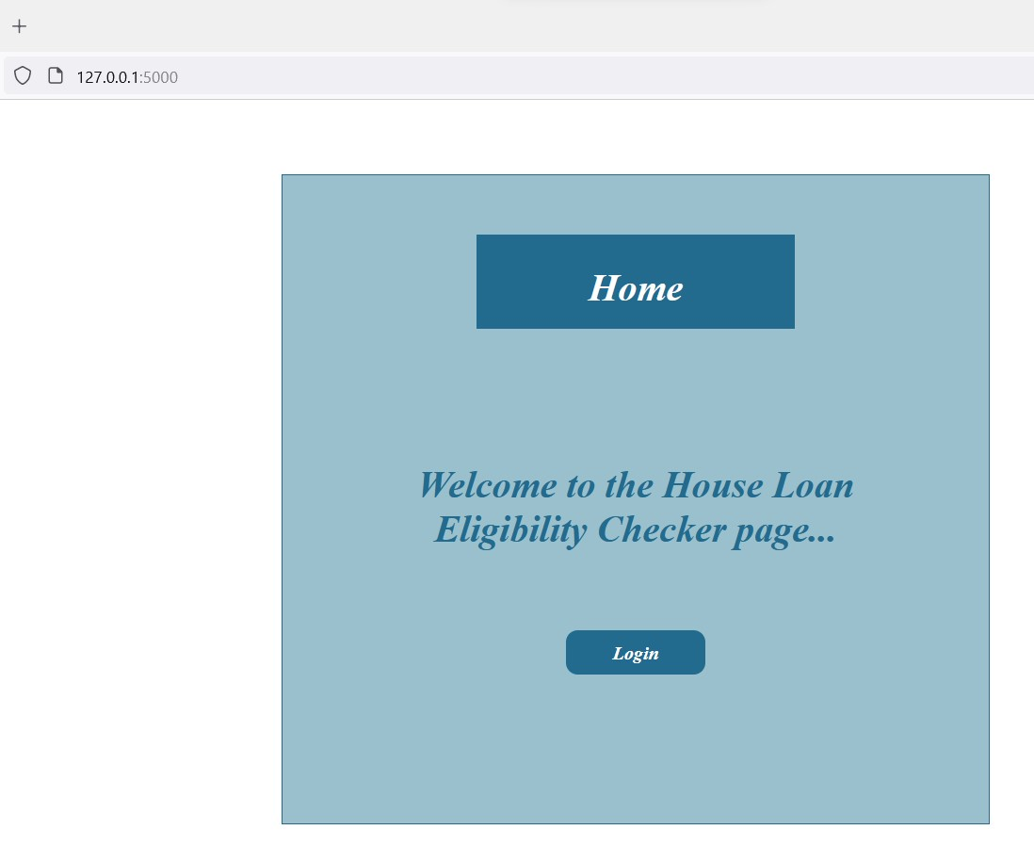

- Login Screen
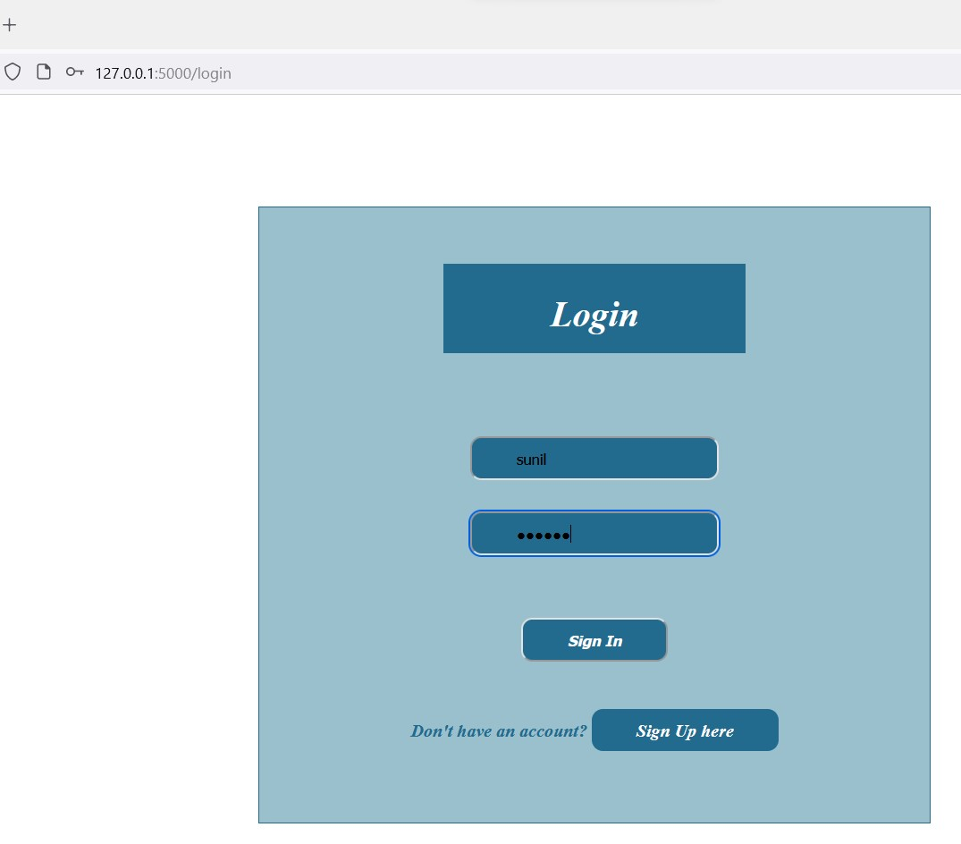

- Login Incorrect

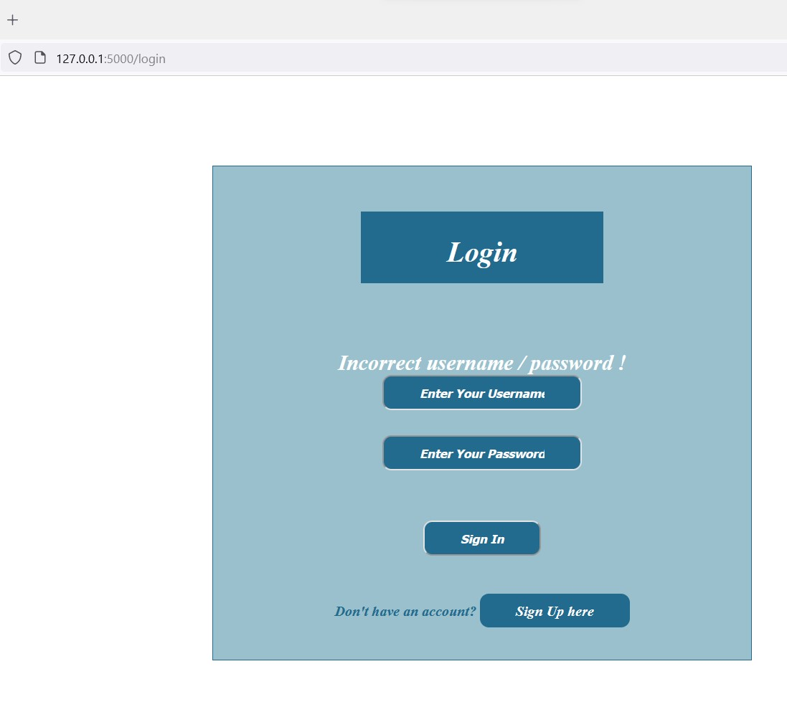

- Register Users Screen after clicking Sign Up here button.
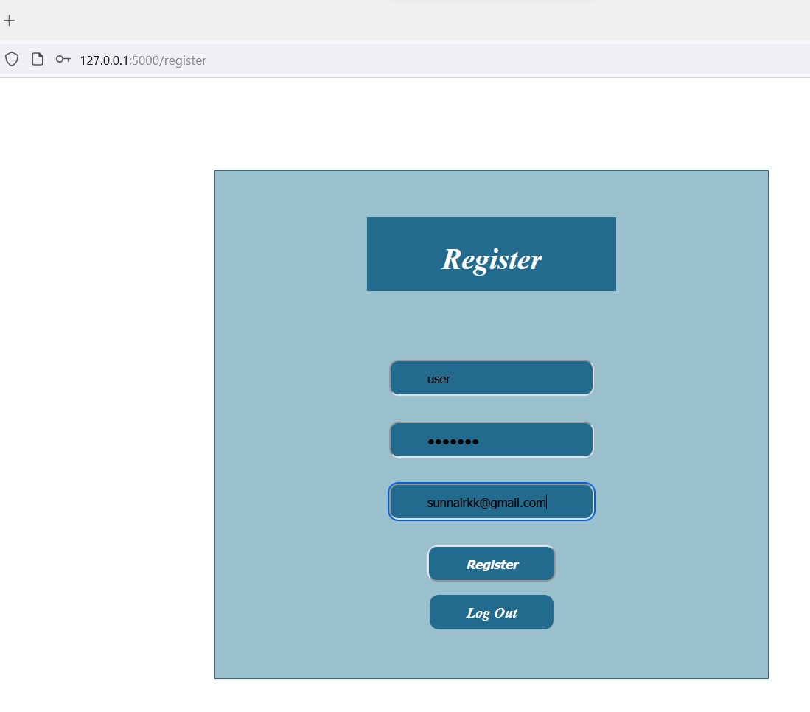

- MySQL Table data before Register User

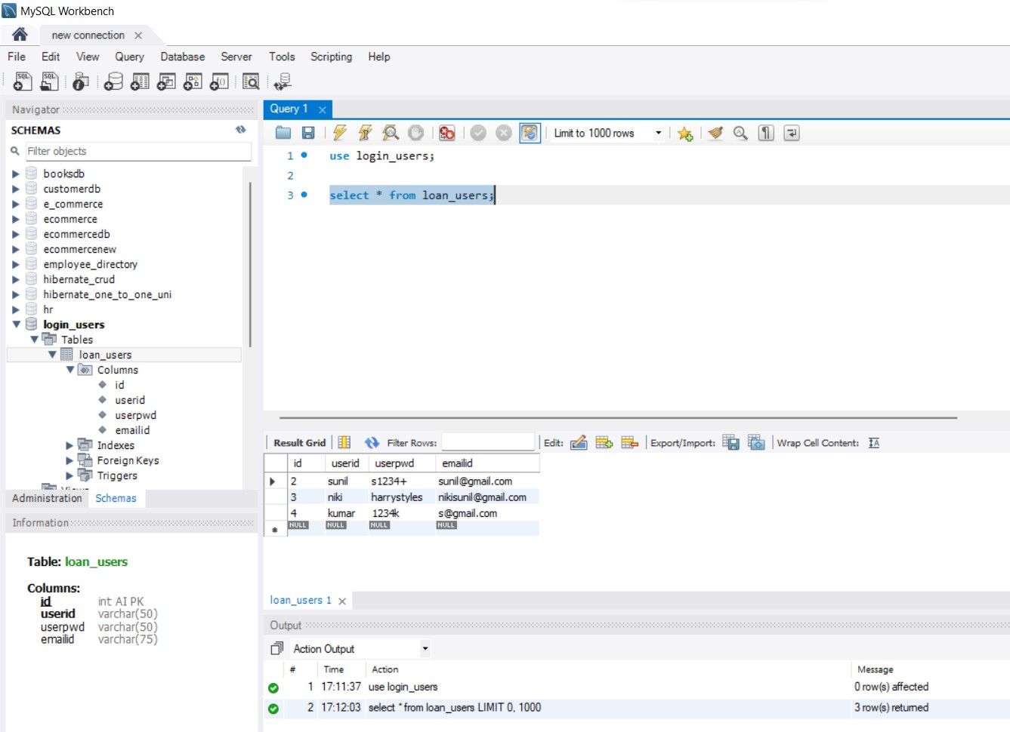

- Register Successful – User Registered
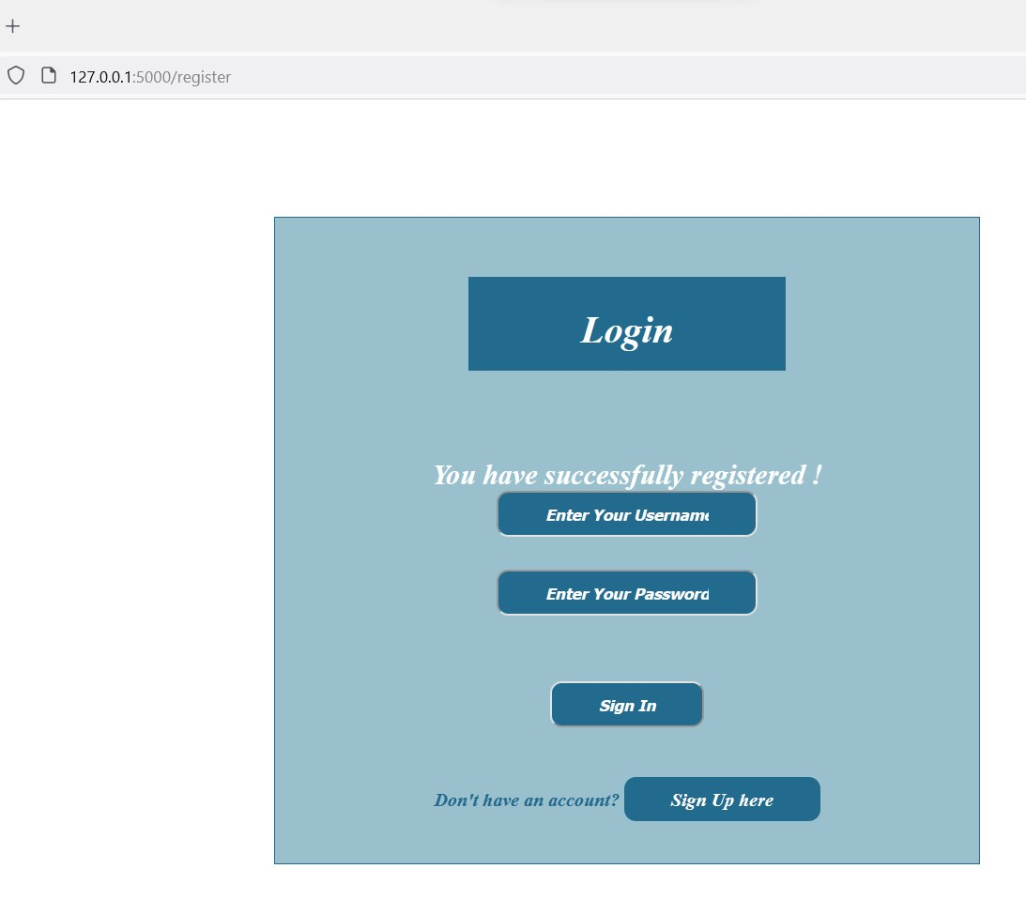

- MySQL Table data after Successfully Registered User

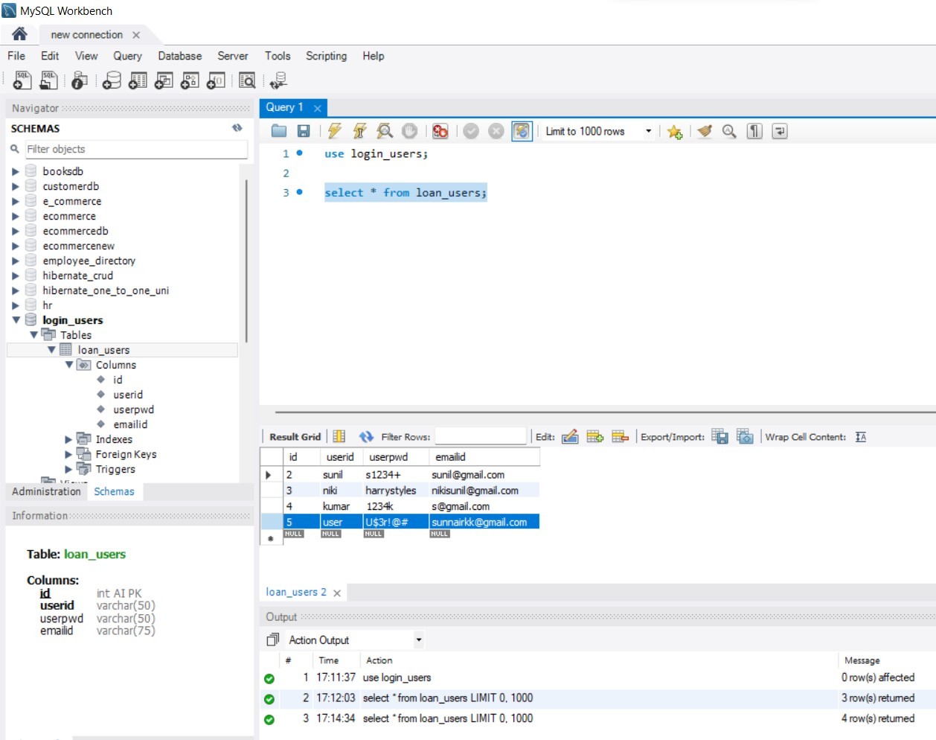

- Login to App using the User created
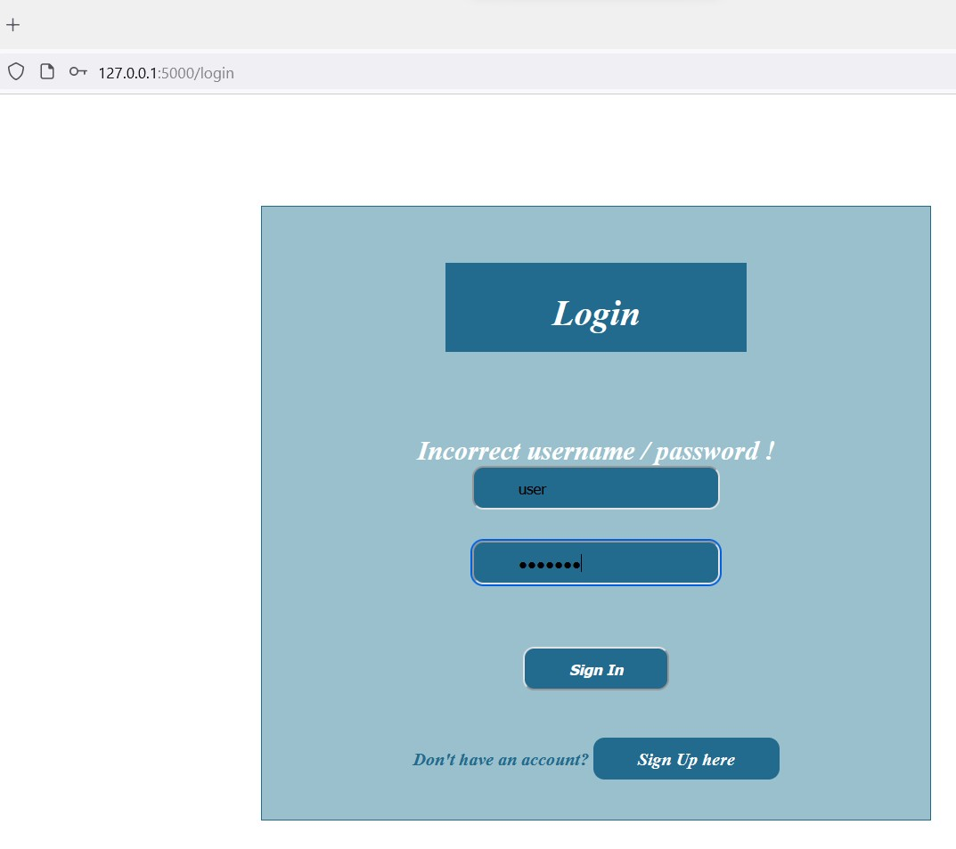

- Home Loan Prediction Screen after Successfully Login into App
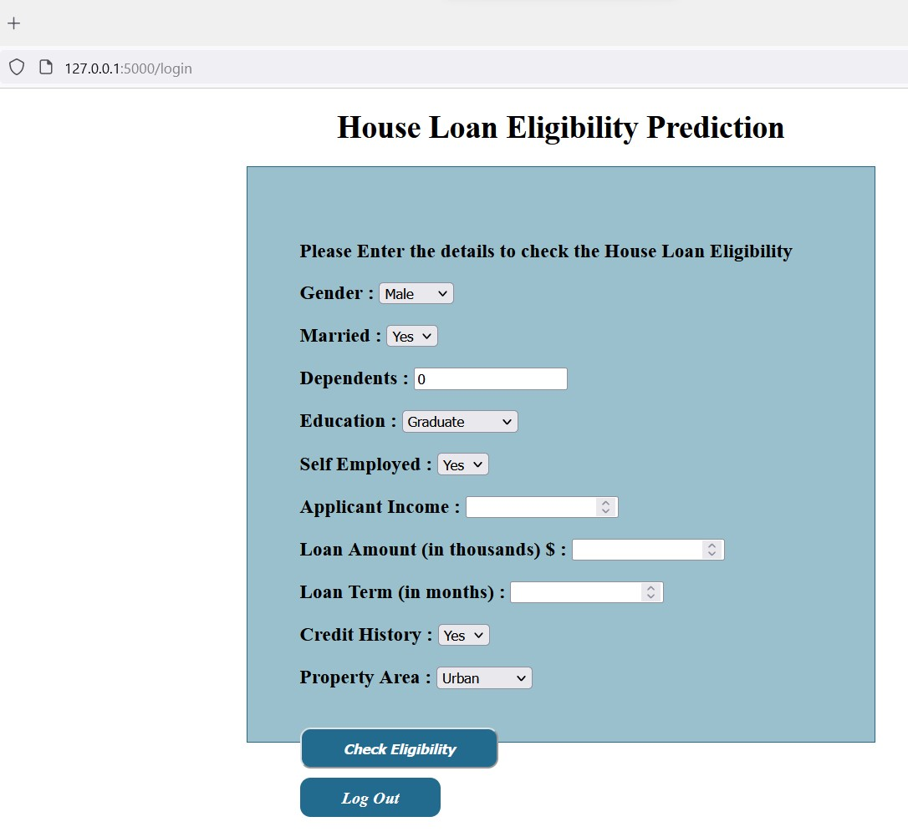

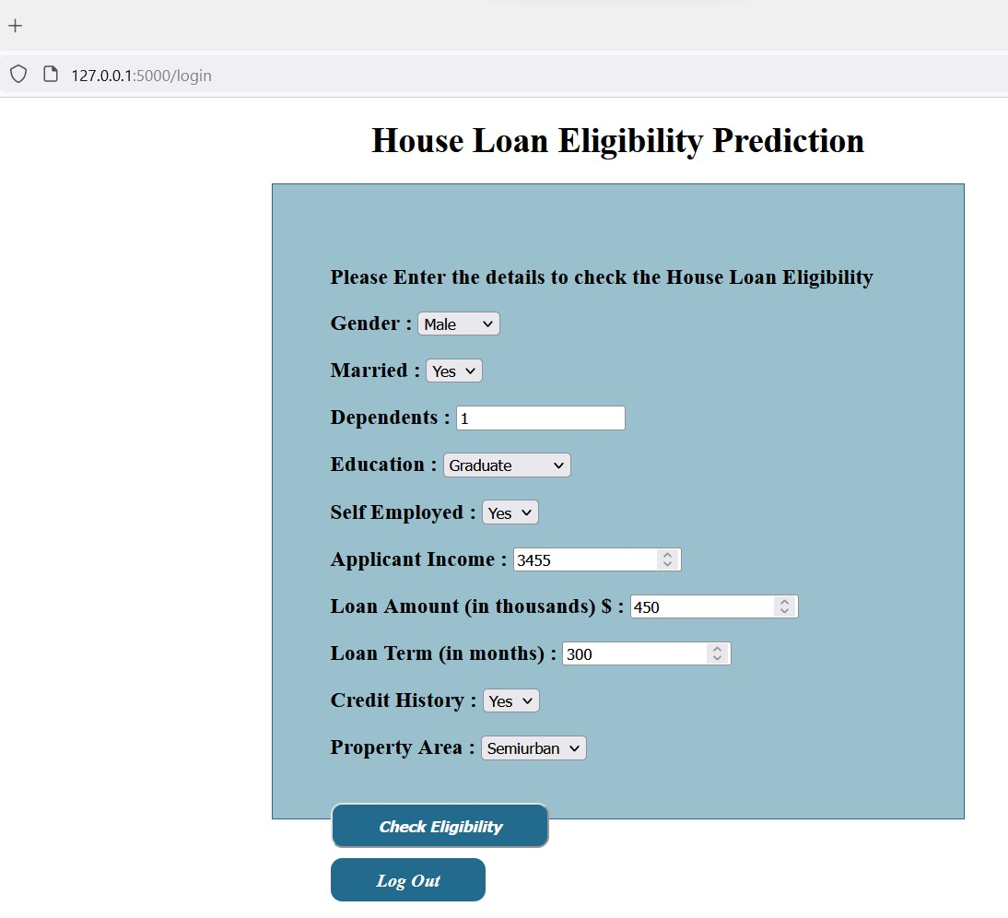
- Enter Details to Predictor

- Result after Clicking the Eligibility Checker Button
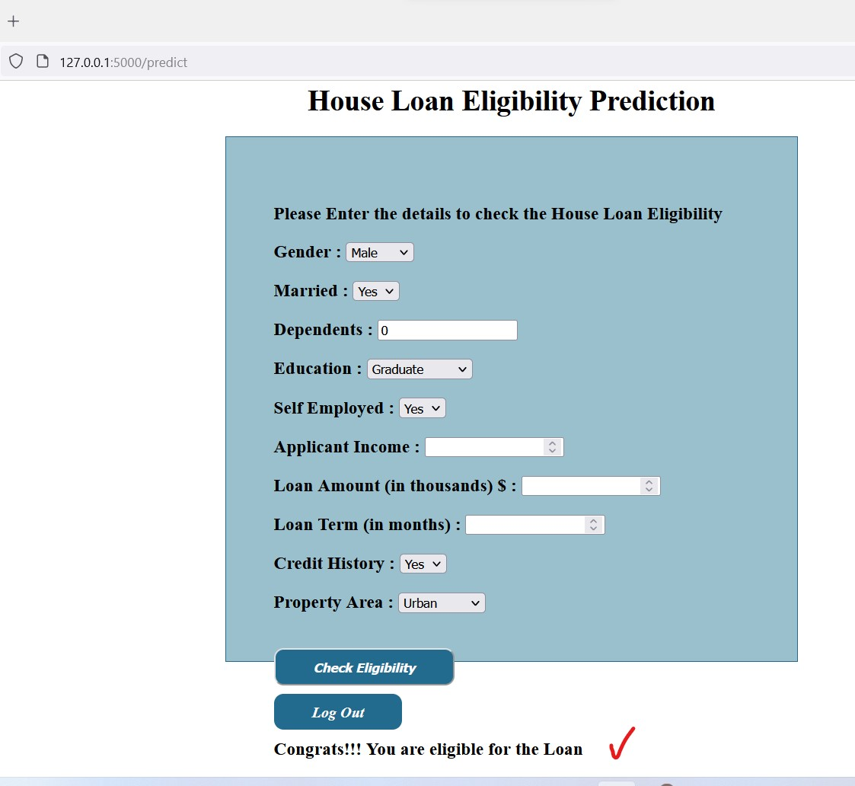

- Logout to Home Screen

End of Document.

